**Project title-**

**Face Mask Detection**

**Submitted by:**

1. **Rakesh kumar (1711010047)**
2. **Diwakar kumar yadav ( 1711010024)**
3. **Sachin kumar (1811010907)**

**in partial fulfilment for the award of the degree**

**of**

**BACHELOR OF TECHONOLOGY**

**IN**

**COMPUTER SCIENCE AND ENGINEERING**

**at**



**INSTITUTE OF ENGINEERING AND RURAL TECHNOLOGY**

**PRAYAGRAJ, UP (INDIA)**

**(AFFILIATED TO DR. A.P.J. ABDUL KALAM TECHNICAL UNIVERSITY,**

**UTTER PRADESH, LUCKNOW (INDIA)**

**MONTH & YEAR**

**June 2021**

**DECLARATION**

**I hereby declare that the project entitled “Face Mask Detection ”**

**Submitted for the B. Tech. (CSE) degree is my original work and the project has not formed the basis for the award of any other degree, diploma, fellowship or any other similar titles.**

**Signature of the Student**

**Place: Prayagraj**

**Date:27/06/2021**

**ii**

**CERTIFICATE**

This is to certify that the project titled “**Face Mask Detection** ” is the bona fide work carried out by Rakesh Kumar, a student of B Tech (CSE) of INSTITUTE OF ENGINEERING AND RURAL TECHNOLOGY PRAYAGRAJ, UP (INDIA) affiliated to DR. A.P.J. ABDUL KALAM TECHNICAL UNIVERSITY, UTTER PRADESH, LUCKNOW (INDIA)during the academic year 2018-19, in partial fulfilment of the requirements for the award of the degree of Bachelor of Technology (Computer Science and Engineering ) and that the project has not formed the basis for the award previously of any other degree, diploma, fellowship or any other similar title.

**Signature of the Guide**

**Place: Prayagraj**

**Date: 27/06/2021**

**iii**

**ACKNOWLEDGEMENT**

Acknowledgements

We are profoundly grateful to Prof. Rajdeep Chatterjee for his expert guidance

and continuous encouragement throughout to see that this project rights its target

since its commencement to its completion

Acknowledgements

We are profoundly grateful to Prof. Rajdeep Chatterjee for his expert guidance

and continuous encouragement throughout to see that this project rights its target

since its commencement to its completion

Acknowledgements

We are profoundly grateful to Prof. Rajdeep Chatterjee for his expert guidance

and continuous encouragement throughout to see that this project rights its target

since its commencement to its completion

Acknowledgements

We are profoundly grateful to Prof. Rajdeep Chatterjee for his expert guidance

and continuous encouragement throughout to see that this project rights its target

since its commencement to its completion

Acknowledgements

We are profoundly grateful to Prof. Rajdeep Chatterjee for his expert guidance

and continuous encouragement throughout to see that this project rights its target

since its commencement to its completion

Acknowledgements

We are profoundly grateful to Prof. Rajdeep Chatterjee for his expert guidance

and continuous encouragement throughout to see that this project rights its target

since its commencement to its completion

We are profoundly grateful to Prof. Rajdeep Chatterjee for his expert guidance

and continuous encouragement throughout to see that this project rights its target

since its commencement to its completion

We are profoundly grateful to prof. INDUBHUSAN DUBEY for his expert guidance

and continuous encouragement throughout to see that this project rights its target

since its commencement to its completion…..

Rakesh kumar 1711010047

Diwakar kumar yadav 1711010024

Sachin kumar 1811010907

iv

**ABSTRACT**

Face mask detection has been a very active research area from 2020 .During COVID-19 pandemic ,it takes a major role .Wearing a face mask has become a routine from past year.

Today in every sector like government ,private or market or hospital or any other places where we have to go ,we have to wear mask not for only our safety but also our family as well as our society safety .This paper presents a simplified approach to achieve using some basic machine learning packages like opencv2,numpy,matplotlib,sklearn,keras.

It detects the face of human and then identifies if they have wear a mask or not. If face of human are in motion then it also detect the mask they wore or not.

The method attains accuracy 89.53 and 90.03% respectively on final test data .we explore optimized values of parameters using the Sequential Convolutional Neural Network.

V

**Table of contents**

Title Page I

Declaration of the Student ii

Certificate of the Guide iii

Abstract iv

Acknowledgement v

Introduction 1

Related Work 2

Dataset 3

Incorporated packages 4

(i)Tensor flow

(ii)Keras

(iii)opencv

(iv)mobilenet 5

The proposed method 6

Result and Analysis 8

Conclusion 10

Future scope 10

Reference 11

Vi

**Introduction**

Computer vision is the part of A.I in which by the computer calculation power to retrieve useful information from given datasets. These datasets are either images form or in video form.

The use of computer vision have many ways as our use cases. In 2019 ,According to WHO officials report ,coronavirus disease (covid-19) has spread and infected globally over 18 cr people causing over 39 lakh deaths .many people infect with covid-19 virus have experienced respiratory illness recover successfully but older people who have diabetes ,cancer ,chronic respiratory disease are serious ill. When peoples having covid-19 comes in close contact with other peoples causing transmission of virus. Wearing a mask is essential for those peoples who have greater risk severe illness from covid-19 disease.

Our research is based on Face mask Detection which uses computer vision to understand the pattern of images or videos provided as input to algo’s. This involves detect the location of face and determine whether it has mask on it or not. Face identification categorically deals with face.Face mask detection has numerous applications like autonomous driving, education, surveillance and so on .Face detection has various use cases ranging from face recognition to capturing facial motions, where the lattercallsfor the face to be revealed withvery high precision. This paper presents a simplified approach to serve the above purpose using machine learning packages such as Tensorflow, keras ,opencv2,and sk learn.

**01/11**

**Related work**

Object detection is one of the best field of image processing and computer vision .object detection and recognition is widely used in wide range of industries .

In object detection ,an image is read and one more object is categorized .The location of object is specified by a boundary called the bounding box. Face detection technology then was developed named as Viola Jones detector that was an optimized technique of using Haarcasscade .However ,it failed because it did not perform so well on faces in dark areas and non-frontal faces.

In the past, many datasets for face detection were developed to form an impression of face mask detection models. Large datasets are much more needed for making better training and testing data and perform real-world applications in a much simpler way. This calls for various deep learning algorithms which can read faces and mask straight from the data provided by the user.

Face mask detection model habe many variations .In Boosting0based classification ,boosted cascades with easy haar features were introduced using viola jones face detector which was failed .Then a Multiview face mask detector was made motivated by viola jones. Then model made by use decision tree algorithms . In Convolutional Neural Network-based classification, face detector models learn directly from the user's data and then apply several deep learning algorithms on it. In 2007 cascade CNN comes in existence .In further ,for uninhibited circumstances , a Contextual Multi-Scale Region-based Convolutional Neural Network (CMS-RCNN), which brought a significant impact on the face detection models. The Face mask detection model named SSDMNV2has been developed using deep neural network modules from OpenCV and TensorFlow, which contains a Single Shot Multibox Detector object detection model.

The main task of this model is to correctly detect the faces from images and then identify if it has a mask on it or not.

02/11

**DATASET**

Face mask detection model have two datasets which are used . Dataset1 consist of 1900 images with people wearing their Face mask and Dataset 2 consist of 1900 images with people not wearing their face masks . The dataset used in for training the model in a given approach was a combination of various open-source datasets and pictures, which included data from Kaggle's ,Github.

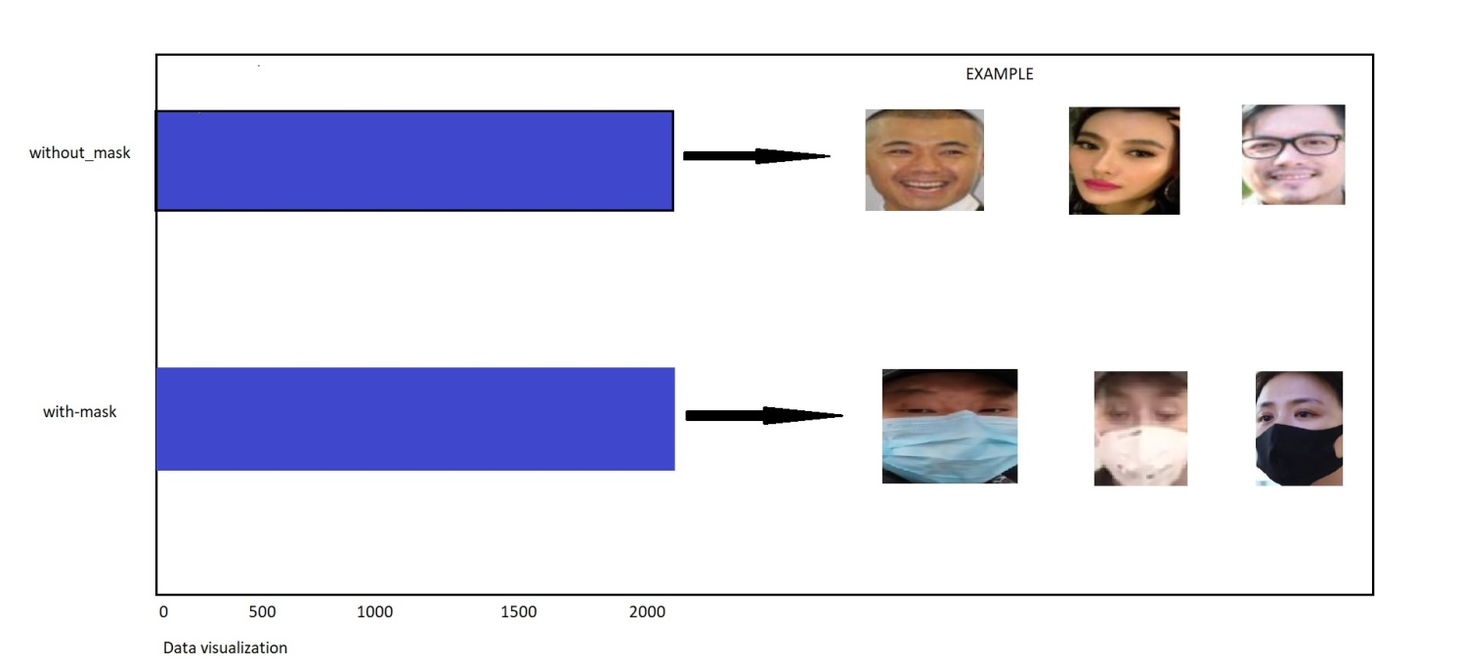

03/11

**INCORPORATED PACKAGES**

1. **Tensorflow**

Implementing machine learning model is far less difficult than it used to be , thanks to machine learning framework such as tensor flow –that ease the process of acquire data ,training models, serving prediction, and refining future results. Tensorflow is an open source library for numerical computation and large scale machine learning . TensorFlow can train and run deep neural networks for handwritten digit classification, image recognition, word embeddings, recurrent neural networks, sequence-to-sequence models for machine translation, natural language processing, and PDE (partial differential equation) based simulation. In presented model ,CNN architecture uses tensorlow at backend. It also used for reshaping the image in data processing.

1. **Keras**

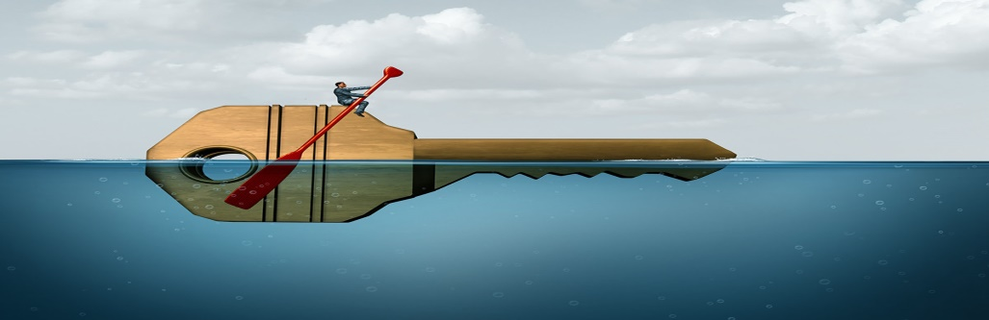

Keras is one of the high level neural network APIs .it is written in python and supports multiple back end neural network computation engines. Tensor flow has adopted keras as the high level API . Keras have core data structures as layers and models.it gives primary and building units for creations and transportation of machine learning arrangements with better velocity.

1. **OPENCV**

OpenCV(Open source computer vision library ),an open-source computer vision and ML software library ,is used to differentiate and identify faces ,identify objects ,follow eye gesture ,track camera actions ,expel red eyes from pictures taken and so on. The first OpenCV version was 1.0 openCV is released under a BSD license and hence its free for both academic and commercial use .Applications of OpenCV are Face recognition ,number of people ,vehicle counting,street view image ,video/image search and retrieval and so on.The presented model makes use of theae feature of openCV in resizing and color conversion of data images .

04/11

1. MOBILENETV2

MobiileNetV2 is predicated on the thought of mobileV1,using deeply intelligent separable convolution as an efficient building piece.It has multiple kayers below.in this model ,we will use library in tensorflow to make a mobilenetV2 model, the load of each layer within the model is predefined consist of image data set.

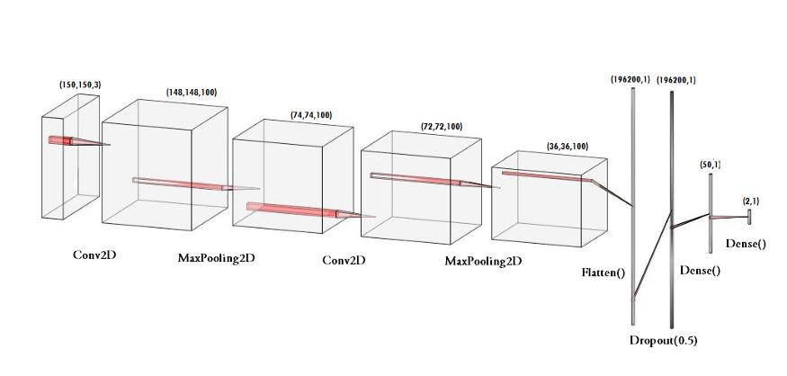

MobileNet use  **depthwise separable convolutions.**It **reduces the number of parameters** when compared to the network with regular convolutions with the same depth in the nets. This results in lightweight deep neural networks.

**05/11**

**THE PROPOSED METHOD**

The proposed method consist of use of Convolution neural network(CNN) connected to layers of dense neurons. But we neglect the layer of CNN and use Mobilenet so that our output comes faster .mobilenet is little bit low accuracy as compared to CNN.

1. Train mask Detector model using MobileNetV2

2. Apply face mask detector over images /live video stream.

Step1. Data visualization

Let us visualize the total number of images in dataset in two categories.

We see that there are 1900 images in with mask category and 1900 images

without mask category.

Step2. Data Augmentation

In next step,we expand the data set to include a larger number of images for training.

We use image data generator as data augmentation .it creates many images from single images .

We rotate images ,flip each image ,zoom range choose ,height –width of images choose.

Totl= ImageDataGenerator(  
  
 rotation_range=20,  
 zoom_range=0.15,  
 width_shift_range=0.2,  
 height_shift_range=0.2,  
 shear_range=0.15,  
 horizontal_flip=True,  
 fill_mode=”nearest”,  
 rescale=None)

Step 3. Splitting the data

In this step ,we divide the data into a training set and testing set. The training set contain images which the CNN model will be trained and testing set in which the model is tested .

In our Model ,We use split_size =0.67,which means that 67% of total images will enter in training set and remaining in test set.

06/11

We make two models ,first model called Primary model on which our training data is being trained and second one is Secondary Model on which we test our data.

Step 4. Building the Model

In next step, construct Secondary model that will be placed on top of primary model .

We use Adam ,dense ,Labelbinarizer to build our CNN based MobileNetV2 model.

We use ADAM optimizer and binary croosentropy as loss function .

ADAM is optimizer is also similar to “relu” which is always goto optimizer for any image prediction method.

Step 5. Training the MobileNetv2 Model

This is the main step in which we out images into training set and test set to use the sequence model built by keras library. I have trained the model for 10 epochs .

H = model.fit(  
 totl.flow(trainX, trainY, batch_size=BS),  
 steps_per_epoch=len(trainX) // BS,  
 validation_data=(testX, testY),  
 validation_steps=len(testX) // BS,  
 epochs=EPOCHS)

Step 6. Labelling the Information

We label the result with two possible outcomes ( 0 as without mask and 1 as with mask).Set the color of bounding box with RGB colors .

label = “Mask” if mask > withoutMask else “No Mask”  
color = (255,0, 0) if label == “Mask” else (0, 0, 255)

Step 7.Import the program and detect the faces with or without mask

In next step ,we use pc’s webcam to detect if we are wearing a mask or not. After that we use opencv library to run a infinite loop to use our webcam ,where cascade can detect faces. To quit our web cam ,we initialized “q” ,by pressing it ,our webcam will stop .

07/11

**Result and Analysis**

Our model is trained and tested upon two datasets.Dataset1 has with mask images and dataset2 has without mask .The technique of OpenCV deep neural networks used in this model generated fruitful results. Classification of images are done in model using MobileNetV2 .

The model attains accuracy up to 90% depicts how this optimized accuracy reduce the cost of error .One of main reason behind this is Maxpooling .It gives rudimentary translation invariance as well as it reduce the number of parameters the model has learn.

The experimental result of our model are calculated with MobileNetV2 and ADAM optimizer.

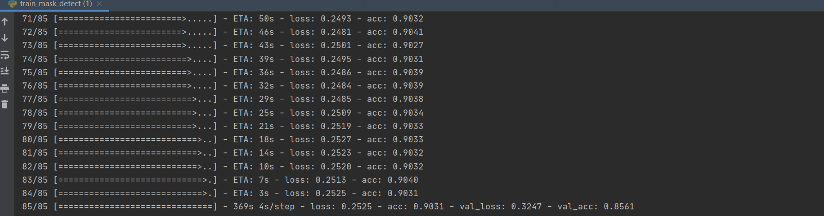

08/11

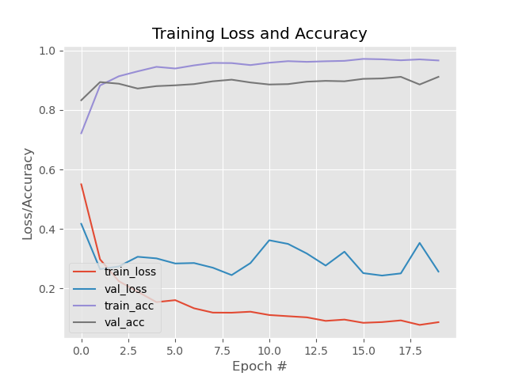

Face mask detection from real image:

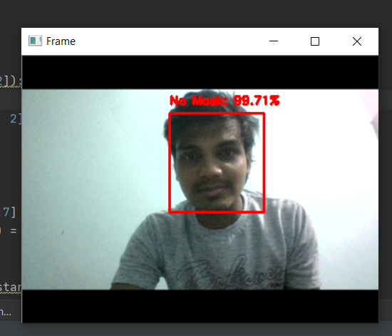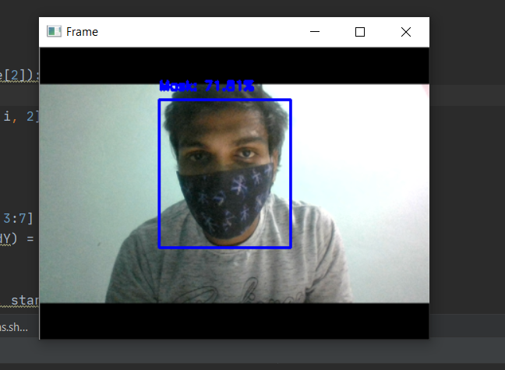

Fig 1 –Showing without mask Fig 2.Showing with mask

09/11

**Conclusion**

In this model ,we observe the learning and performance task. Using Machine learning tools and techniques the method has achieved its accuracy. Wearing a face mask have important in today life in covid-19 pandemic. Our face mask detection is trained on MobileNetV2 and we used different tools like OpenCV, Tensorflow, Keras and python libraries to detect whether a person is wearing a mask or not . Our model were tested with image as well as real time video stream .

**Future scope :**

The current situation in the world for pandemic of Corona virus from all the people are fighting together by taking all means of Health suggestion From W.H.O .Our model is which is based on MobileNet classifier is one of the best technique which is implemented to overcome this Covid-19 virus .It will helpful business oragnisation , government and private sector in their security purpose for cctv .

Other factors for wearing mask is because of increase of pollution .people who have difficulty in breathing because of poisonous gas have wear their mask to protest themselves.

It will also helpful for medical purpose and chemical factory to identify who have wear their mask or not.

10/11

**REFERENCE**

1. Keras-team Github (/<https://github.com/keras-team/keras>/)
2. Opencv Geeksforgrrks (<https://www.geeksforgeeks.org/opencv-python-tutorial/>)
3. Article on face mask Pyimagesearch (<https://www.pyimagesearch.com/2020/05/04/covid-19-face-mask-detector-with-opencv-keras-tensorflow-and-deep-learning/>)
4. Image clasiification with mobile net ,medium (<https://medium.com/analytics-vidhya/image-classification-with-mobilenet-cc6fbb2cd470>)
5. Ariya das ,Mohammad wasif Ansari :IEEEXplore (<https://ieeexplore.ieee.org/>)

11/11